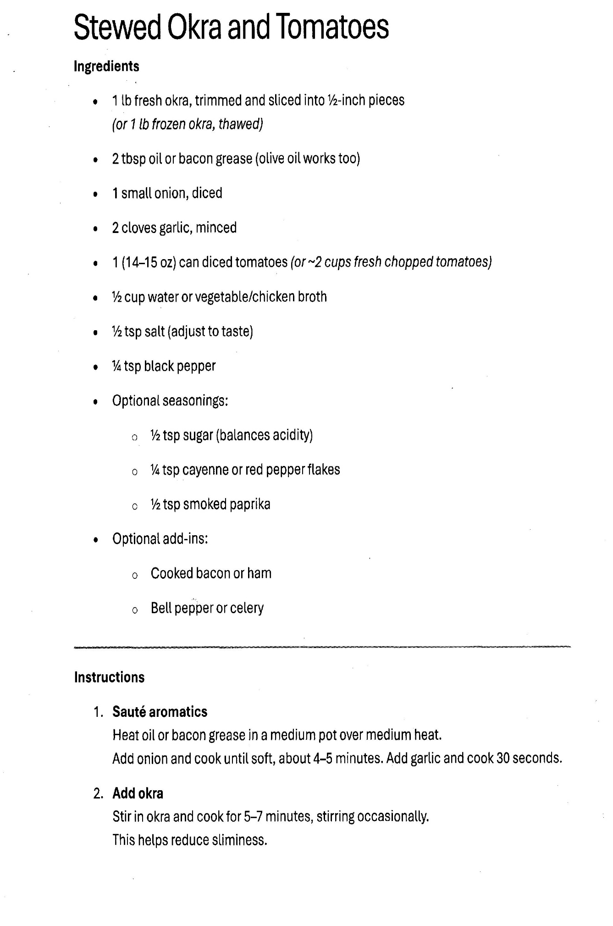
Stewed Okra and Tomatoes: page 2
This is the most critical part of the Stewed Okra and Tomatoes! That 5–7 minute "dry" sauté is the secret to a great texture, as it sears the outside of the okra before you add any liquid.

3. Add Tomatoes and Seasoning
- Stir in Tomatoes: Add 1 can (14.5 oz) of diced tomatoes (with their juices) or 2 cups of fresh chopped tomatoes to the pot.
- Liquid: If the mixture looks too dry, add a 1/4 cup of water or chicken broth.
- Season: Now is the time to add your sugar (just a pinch to cut the acidity of the tomatoes), paprika, and cayenne for heat. Don't forget salt and black pepper to taste.

4. Simmer the Stewed Okra and Tomatoes
- Low and Slow: Reduce the heat to low. Cover the pot and simmer for 15–20 minutes.
- The Goal: You want the okra to be tender but not mushy, and the tomatoes to have broken down into a thick, savory sauce.

5. Final Touch
- Optional Add-ins: If you used bacon, crumble the crispy pieces back in now. If you used bell peppers, they should have gone in during the "aromatics" step at the very beginning.
- Serve: This Stewed Okra and Tomatoes is traditionally served over white rice or as a side dish for fried fish or cornbread.

