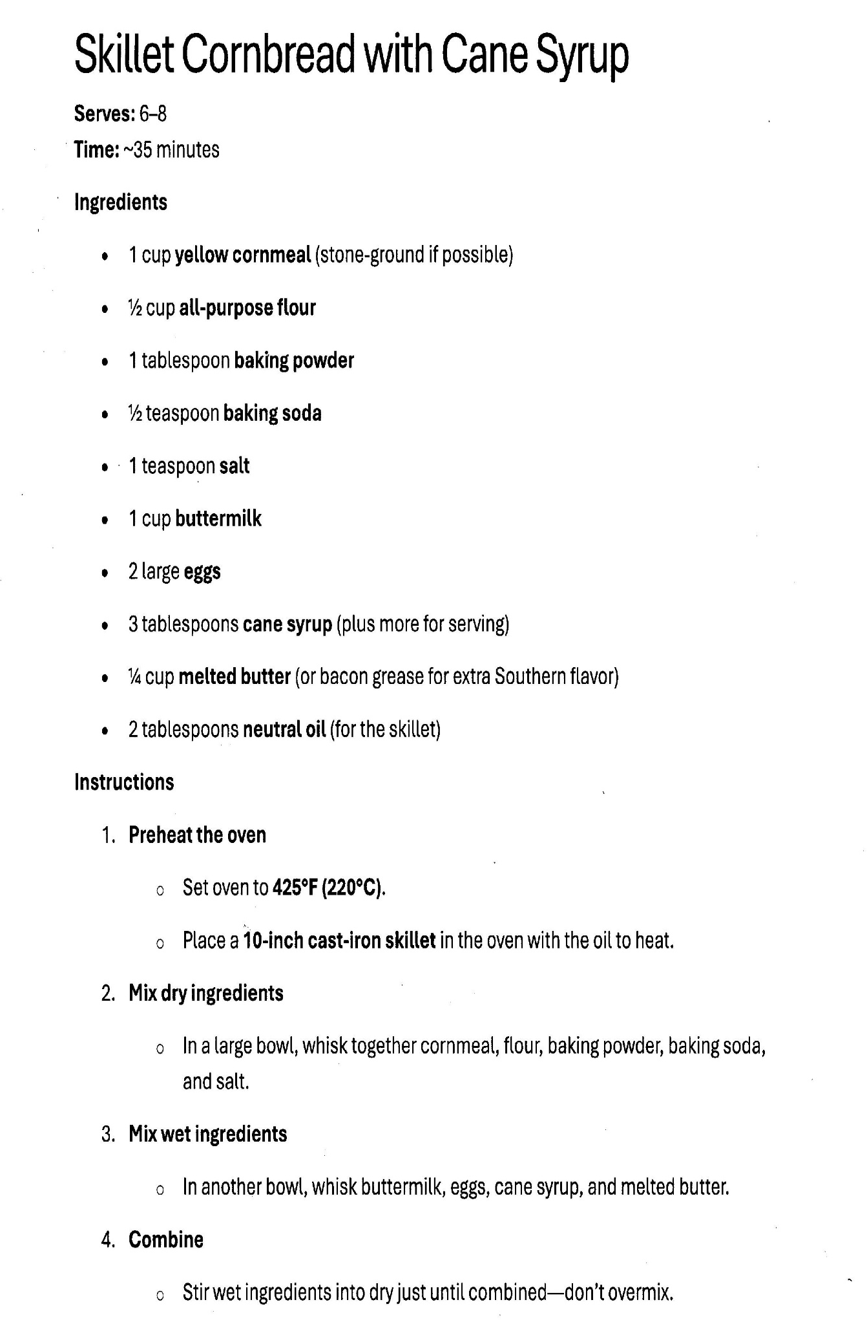

Skillet Cornbread and Cane Syrup

Remaining Instructions (Page 2)
- Prep the Skillet: Place 2 tablespoons of butter (or bacon drippings) into a 10-inch cast-iron skillet. Put the skillet in the preheated oven for 3–5 minutes until the butter is melted and the pan is sizzling hot.
- The Sizzle Pour: Carefully remove the hot skillet from the oven. Pour the batter into the center of the pan. You should hear a sizzle—this is what creates that iconic, crispy golden crust.
- Bake: Place the skillet back into the oven. Bake at 400°F (200°C) for 20–25 minutes.
  - How to tell it's done: The edges should be pulling away from the sides of the pan and the top should be golden brown. A toothpick inserted into the center should come out clean.
- The Cane Syrup Glaze (Optional): For an extra punch of flavor, brush an additional tablespoon of cane syrup over the top of the cornbread immediately after taking it out of the oven.
- Cooling: Let the cornbread rest in the skillet for at least 10 minutes before slicing. This allows the cane syrup to set so the bread doesn't crumble when you cut it.

