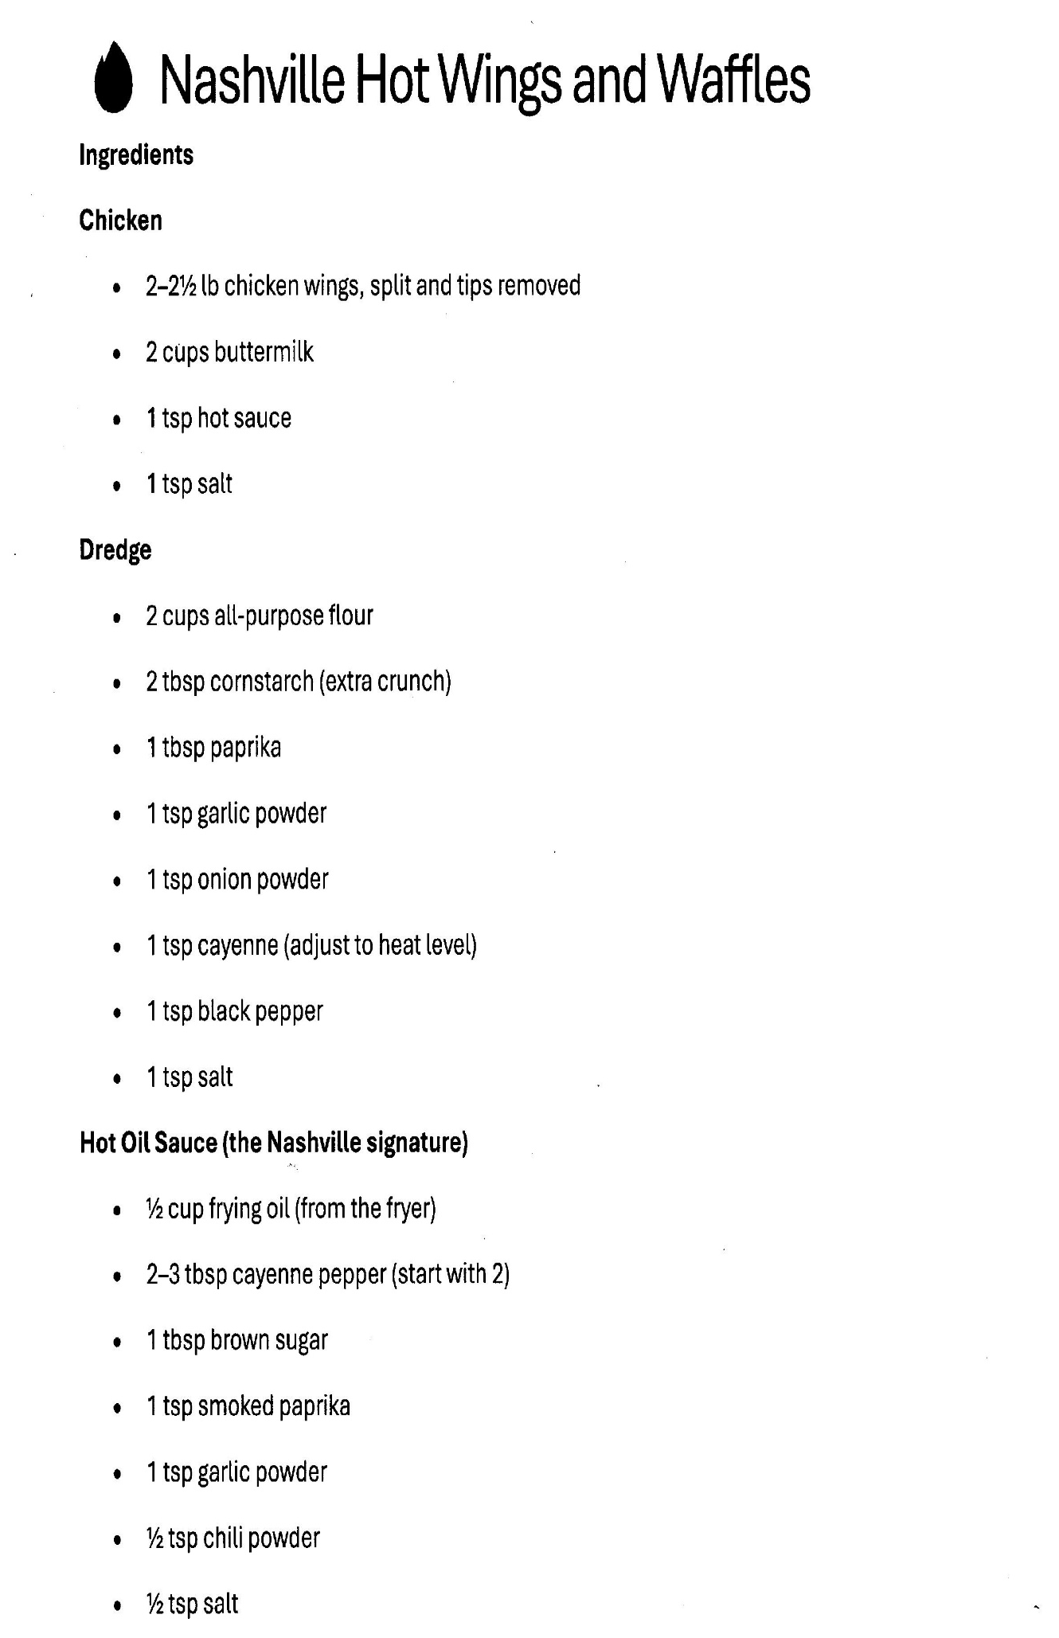

Nashville Hot Chicken and Waffles: Page 2

1. For Frying (Continued)
- Heat the Oil: Fill a heavy skillet or Dutch oven with vegetable oil (about 2 inches deep). Heat to 350°F (175°C).
- Fry: Carefully lower the dredged chicken into the oil. Fry for 6–8 minutes per side (for boneless) or until the internal temperature reaches 165°F.
- Drain: Remove the chicken and let it rest on a wire rack. Do not discard the frying oil yet!

2. Make the Nashville Signature Hot Oil Sauce
- The Mix: In a medium heat-proof bowl, whisk together your spices (typically cayenne, brown sugar, chili powder, garlic powder, and paprika).
- The Secret Step: Carefully ladle 1/2 cup of the hot frying oil into the bowl with the spices. Whisk until the sugar is dissolved and the sauce is a deep, fiery red.
- The Coating: Immediately brush the spicy oil mixture all over the hot fried chicken using a pastry brush (or dunk the chicken directly into the bowl).

3. Prepare the Waffles
- Waffle Batter: While the chicken rests, cook your waffles in a preheated waffle iron until golden and crisp.
- Keep Warm: Place the waffles in a warm oven until you are ready to assemble.

4. Assemble the Nashville Hot Chicken and Waffles
- Plate: Place one or two waffles on a plate and top with a piece of the hot chicken.
- Garnish: Traditionally, this is served with dill pickle slices on top to cut through the heat.
- Finish: Drizzle with plenty of maple syrup or honey. The contrast between the spicy Nashville Hot Chicken and Waffles and the sweet syrup is what makes this dish legendary.

