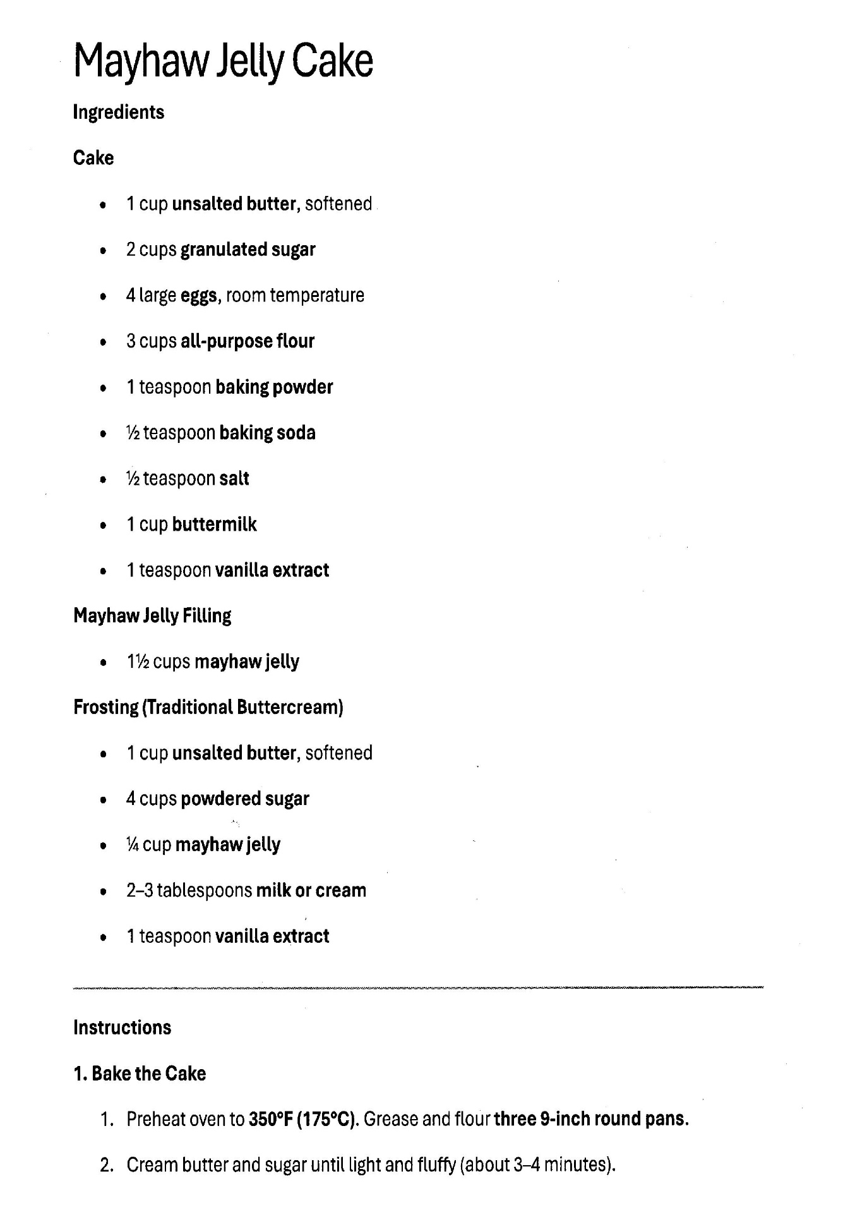
Mayhaw Jelly Cake: page 2

1. Bake Cake (Continued)
- Add Eggs: Beat in eggs one at a time, mixing well after each addition.
- Alternate Dry and Wet: Gradually add your dry ingredients (flour, baking powder, salt) alternating with your liquid (usually buttermilk or milk), starting and ending with the flour mixture. Mix until just combined.
- Bake: Divide the batter evenly between the three 9-inch round pans. Bake for 25–30 minutes or until a toothpick comes out clean.
- Cool: Let the cakes cool in the pans for 10 minutes, then turn them out onto wire racks to cool completely. (This is vital—if the cake is warm, the mayhaw jelly will slide right off!)

2. Assemble with Filling
- First Layer: Place one cake layer on your serving plate. Spread about 1/2 to 3/4 cup of the Mayhaw Jelly evenly over the top, leaving a small border at the edge.
- Stack: Place the second cake layer on top and repeat with another layer of jelly.
- Top Layer: Place the final cake layer on top.

3. Frost the Mayhaw Jelly Cake
- Traditional Buttercream: Prepare your buttercream by beating butter, powdered sugar, vanilla, and a splash of milk until smooth.
- Frosting Technique: You can frost the entire cake, or for a traditional look, frost only the top and sides, leaving the jelly layers visible between the cake rounds (like a naked cake).
- Set: For the best flavor, let the Mayhaw Jelly Cake sit for a few hours before slicing. This allows the tart jelly to slightly soak into the sweet cake layers.

