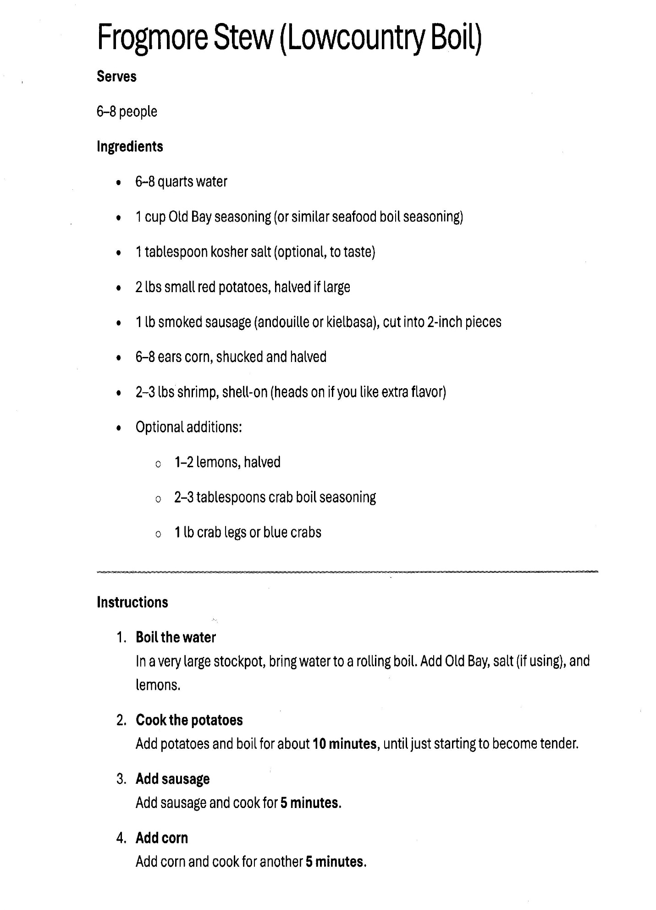

Frogmore Stew (Low Country Boil): page 2

5. Add the Seafood
- Crab First: If you are using the 1 lb crab legs or blue crabs, add them now. Let them boil for about 5 minutes (since they take longer than shrimp).
- The Shrimp: Finally, add the 2 to 3 lb shrimp. Stir them in and cook for only 2–3 minutes. As soon as they turn pink and form a "C" shape, they are done. Do not overcook or they will be hard to peel!

6. The Soak (The Secret Step)
- Turn off the heat. Let everything sit in the flavored water for an additional 5 minutes. This "soak" allows the Frogmore Stew (Low Country Boil) to really absorb the Old Bay and lemon flavors without the heat of the fire toughening the meat.

7. Drain and Serve
- The Traditional Way: Drain the liquid and dump the entire contents of the pot onto a table covered with newspaper or brown butcher paper.
- The Finish: Melt some extra butter on the side for dipping and sprinkle a little more Old Bay over the top while it’s still steaming.

