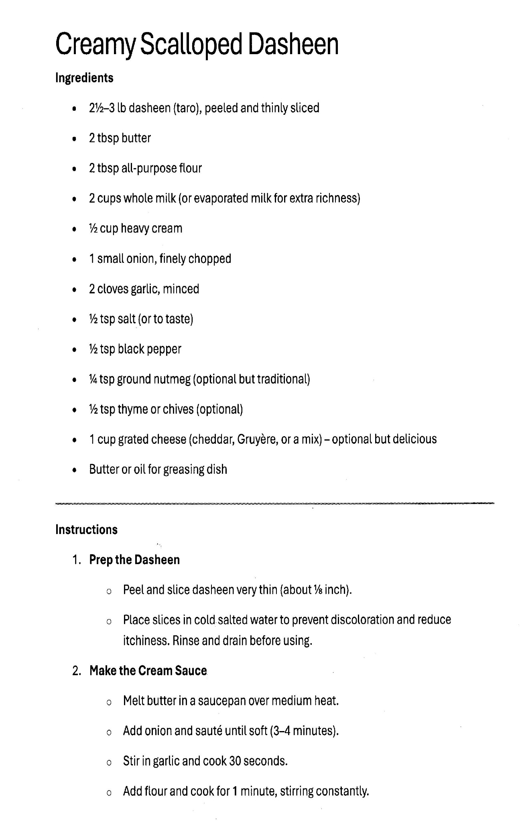

Creamy Scalloped Dasheen: page 2

2. Make the Cream Sauce (Continued)
- Whisk in Liquid: Slowly pour in your milk (usually about 2 to 2 1/2 cups) while whisking constantly to prevent lumps.
- Thicken: Continue to cook over medium heat, stirring, until the sauce thickens enough to coat the back of a spoon.
- Season: Stir in salt, black pepper, and a pinch of nutmeg (which pairs beautifully with dasheen). If the recipe called for cheese, stir in half of it now until melted.

3. Assemble the Dish
- Layer: Grease a baking dish. Place a layer of the sliced, prepped dasheen in the bottom.
- Sauce: Pour a portion of the cream sauce over the layer. Repeat the layers until all the dasheen and sauce are used, ending with a layer of sauce on top.
- Top: Sprinkle the remaining cheese or breadcrumbs over the top.

4. Bake the Creamy Scalloped Dasheen
- Cover and Bake: Cover the dish with foil and bake at 375°F (190°C) for about 30–40 minutes.
- Brown the Top: Remove the foil and bake for another 10–15 minutes until the dasheen is fork-tender and the top is bubbly and golden brown.
- Rest: Let the Creamy Scalloped Dasheen sit for 5–10 minutes before serving to allow the sauce to set.

