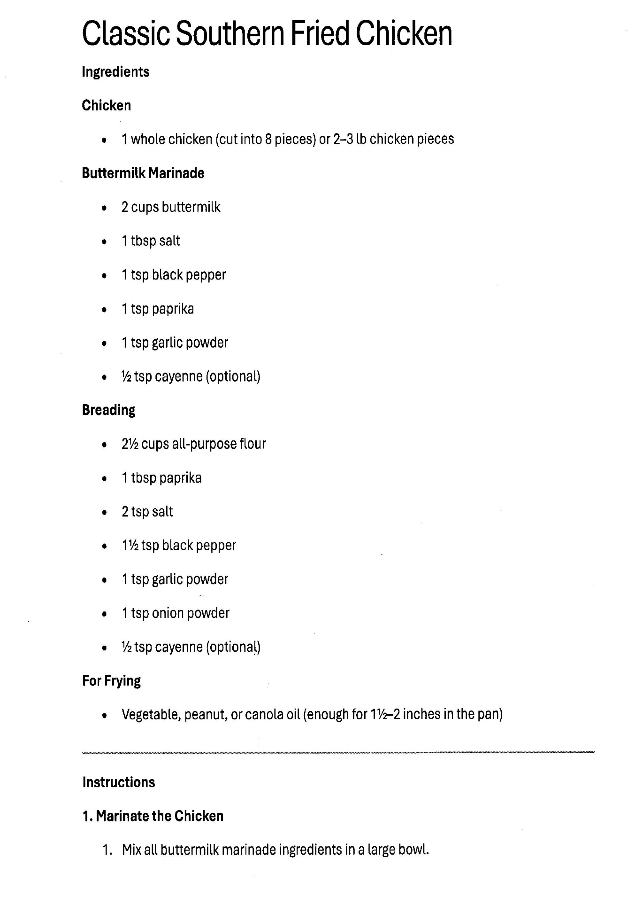
Classic Southern Fried Chicken: page 2

1. Marinate Chicken (Continued)
- Submerge: Add the chicken pieces to the buttermilk mixture, ensuring every piece is well-coated.
- Chill: Cover and refrigerate for at least 4 hours, but preferably overnight. This tenderizes the meat and helps the breading stick later.

2. The Breading Process
- Dredge: Remove chicken from the buttermilk, letting the excess drip off. Dredge each piece thoroughly in your seasoned flour mixture (the breading).
- The "Double Dip" (Optional): For extra crunch, dip the floured chicken back into the buttermilk and then into the flour a second time.
- Rest: Place the breaded chicken on a wire rack for 10–15 minutes before frying. This "sets" the breading so it doesn't fall off in the pan.

3. Fry the Classic Southern Fried Chicken
- Heat: Get that 1 1/2 to 2 inches of oil (usually peanut or vegetable oil) to 350°F. Use a cast-iron skillet if you have one—it holds heat the best!
- Fry in Batches: Carefully place chicken in the pan (skin-side down first). Don't crowd the pan, or the oil temperature will drop and the chicken will get greasy.
- Timing: Fry for 12–15 minutes per side for dark meat (thighs/legs) and 8–10 minutes per side for white meat (breasts). The crust should be a deep golden brown.

4. Drain and Rest
- Wire Rack: Drain the Classic Southern Fried Chicken on a wire rack over a baking sheet (rather than paper towels) to keep the bottom from getting soggy.
- Rest: Let it sit for at least 10 minutes. This allows the juices to redistribute so the first bite is perfectly moist.

