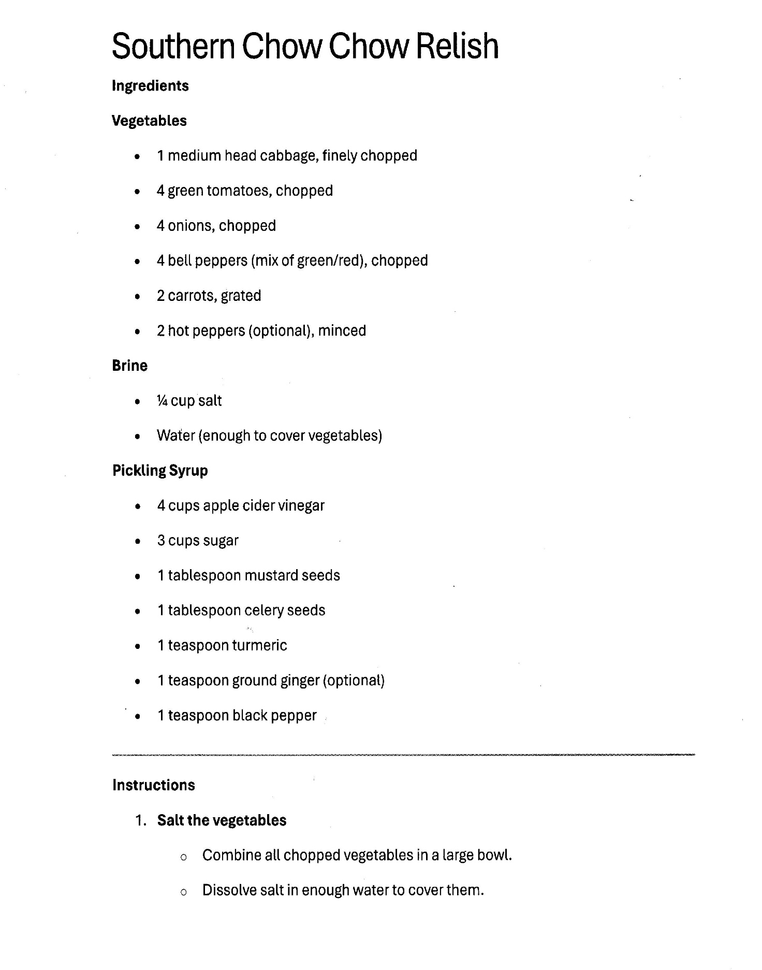

Southern Chow Chow Relish- page 2

2. The Big Soak (4–8 Hours or Overnight)
Now that the veggies are submerged in that salt brine:
- Cover the bowl with plastic wrap or a lid.
- Place it in the refrigerator.
- Let it sit for at least 4 hours, but most old-school recipes prefer overnight. This "cures" the vegetables, drawing out excess moisture so they stay crunchy in the jars instead of getting mushy. DO NOT EXCEED 24 HOURS OR VEGETABLES BECOME TOO SALTY!

3. The Drain and Rinse
Once the soak is over:
- Drain the vegetables into a large colander.
- Discard the salty water. * Rinse the vegetables well under cold running water to wash off the excess salt. (If you skip the rinse, your Chow Chow will be way too salty to eat!)
- Let them drain thoroughly while you prep the syrup.

4. Make the Picking Syrup
In a large, heavy stockpot (non-reactive, like stainless steel or enamel):
- Combine your liquid and sugar: Usually your vinegar, water, and sugar.
- Add the spices: This is where your mustard seeds, celery seeds, turmeric, and ginger go.
- Bring to a boil over medium-high heat, stirring until the sugar is completely dissolved.

5. The Final Simmer
- Add the drained vegetables to the boiling syrup.
- Bring it back to a boil.
- Reduce heat and simmer for about 10 minutes (some recipes go up to 25 depending on how soft you like the cabbage).
- Jar it up: While it's hot, ladle it into your sterilized jars, leaving about 1/2 inch of headspace at the top.

