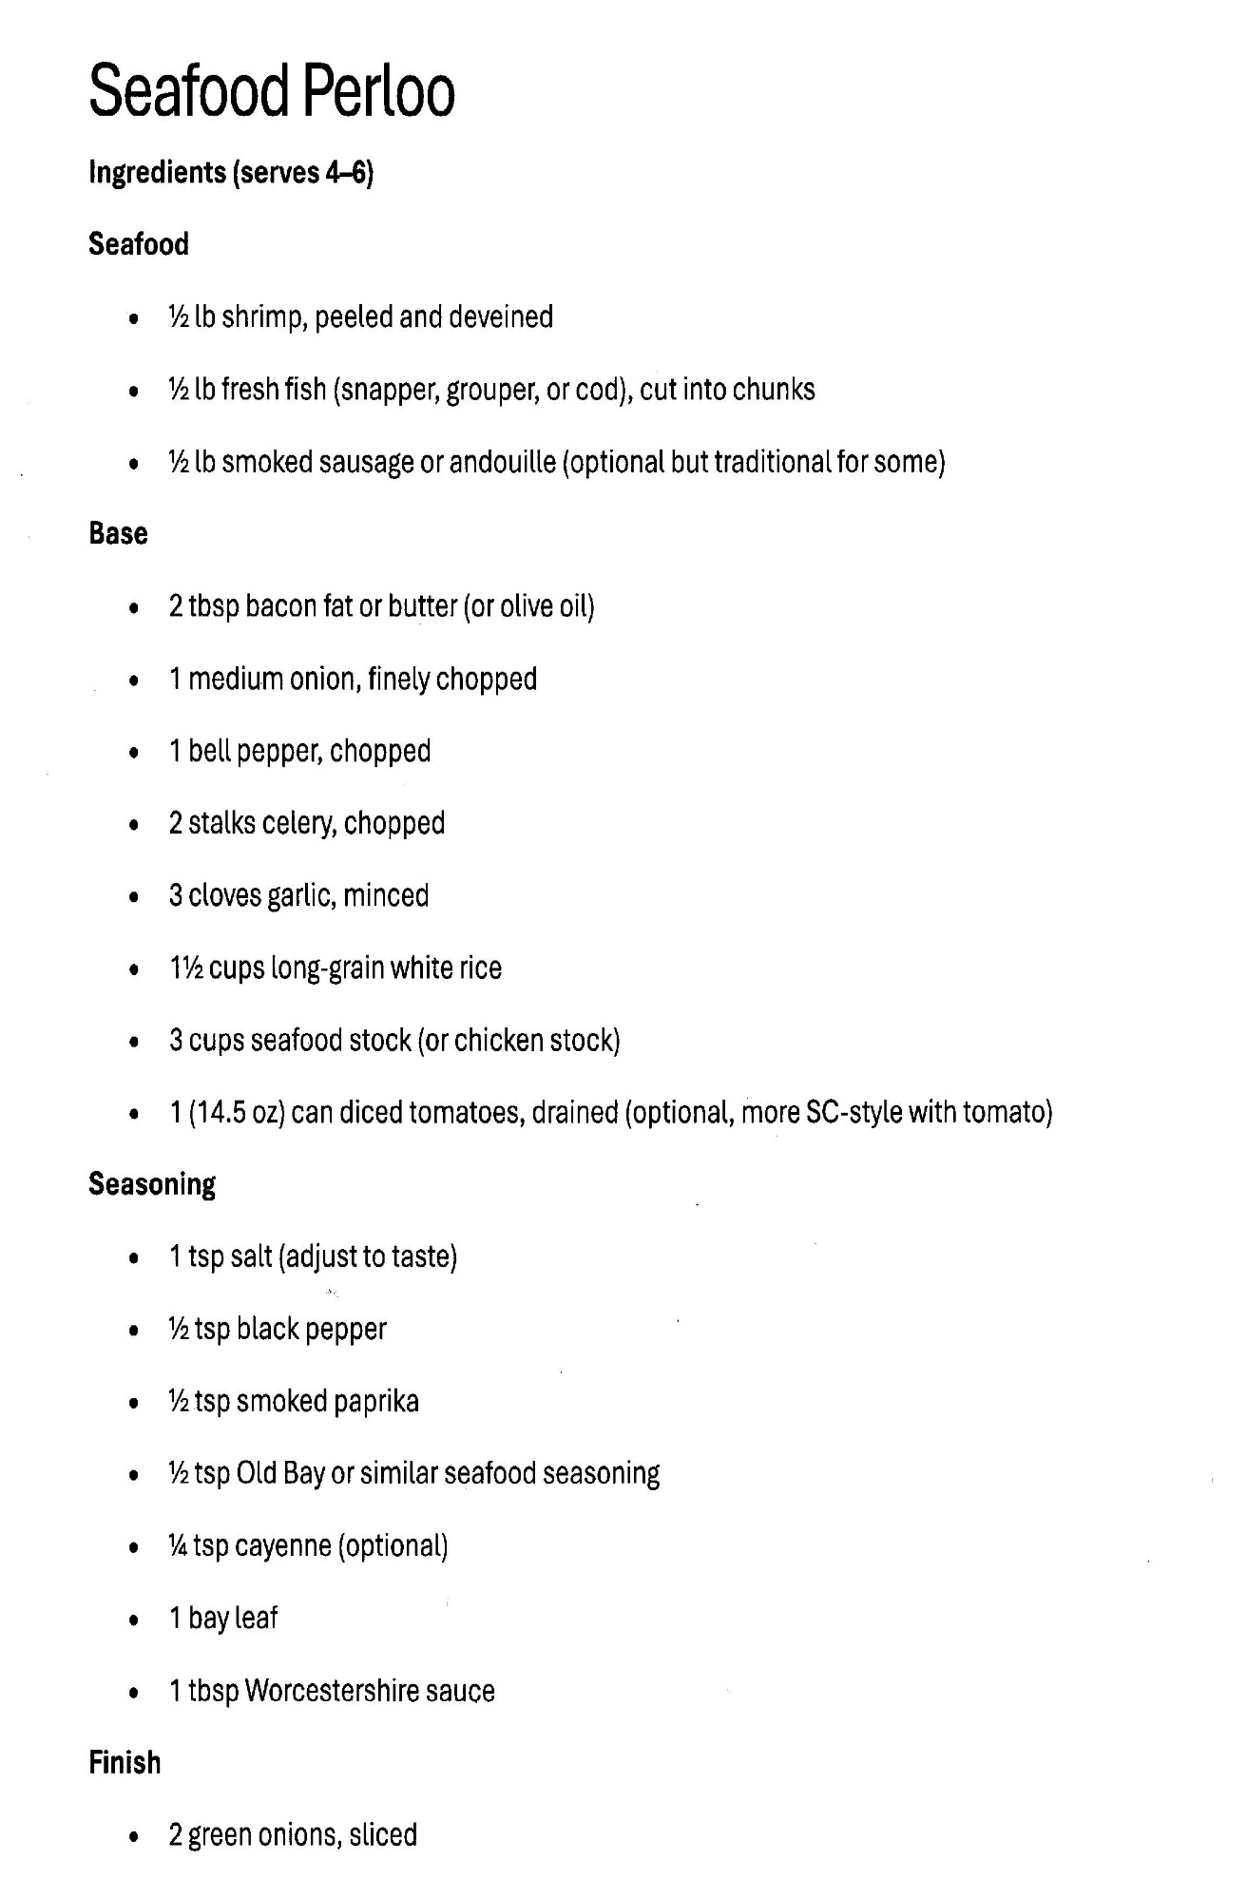
Shrimp Perloo: Instructions (Page 2)
- Sauté the Base: In a large Dutch oven or heavy pot, melt 2 tablespoons of butter (or fry 3-4 strips of bacon and use the drippings). Add your diced onion, celery, and green bell pepper. Sauté over medium heat for 5–7 minutes until the vegetables are soft.
- Toast the Rice: Stir in your rice (usually 1.5 to 2 cups) and the minced garlic. Stir constantly for 2 minutes to toast the rice grains; they should look slightly translucent at the edges.
- Simmer: Add your Seasoning, a can of diced tomatoes with juice, and your seafood stock (about 3 to 4 cups). Bring to a boil, then immediately reduce heat to low. Cover tightly and simmer for 15–18 minutes until the liquid is mostly absorbed and the rice is tender.
- Add the Seafood: Quickly lift the lid and nestle the Shrimp on top of the rice. Do not stir yet! Replace the lid and let it steam on low for 3–5 minutes until the shrimp are pink and opaque.
- The Finish: Turn off the heat. Gently fold the shrimp into the rice. Stir in your 2 sliced green onions and a handful of fresh parsley.
- Rest: Cover the Shrimp Perloo and let it sit for 5 minutes before serving. This allows the flavors to meld and the rice to reach the perfect fluffiness.

