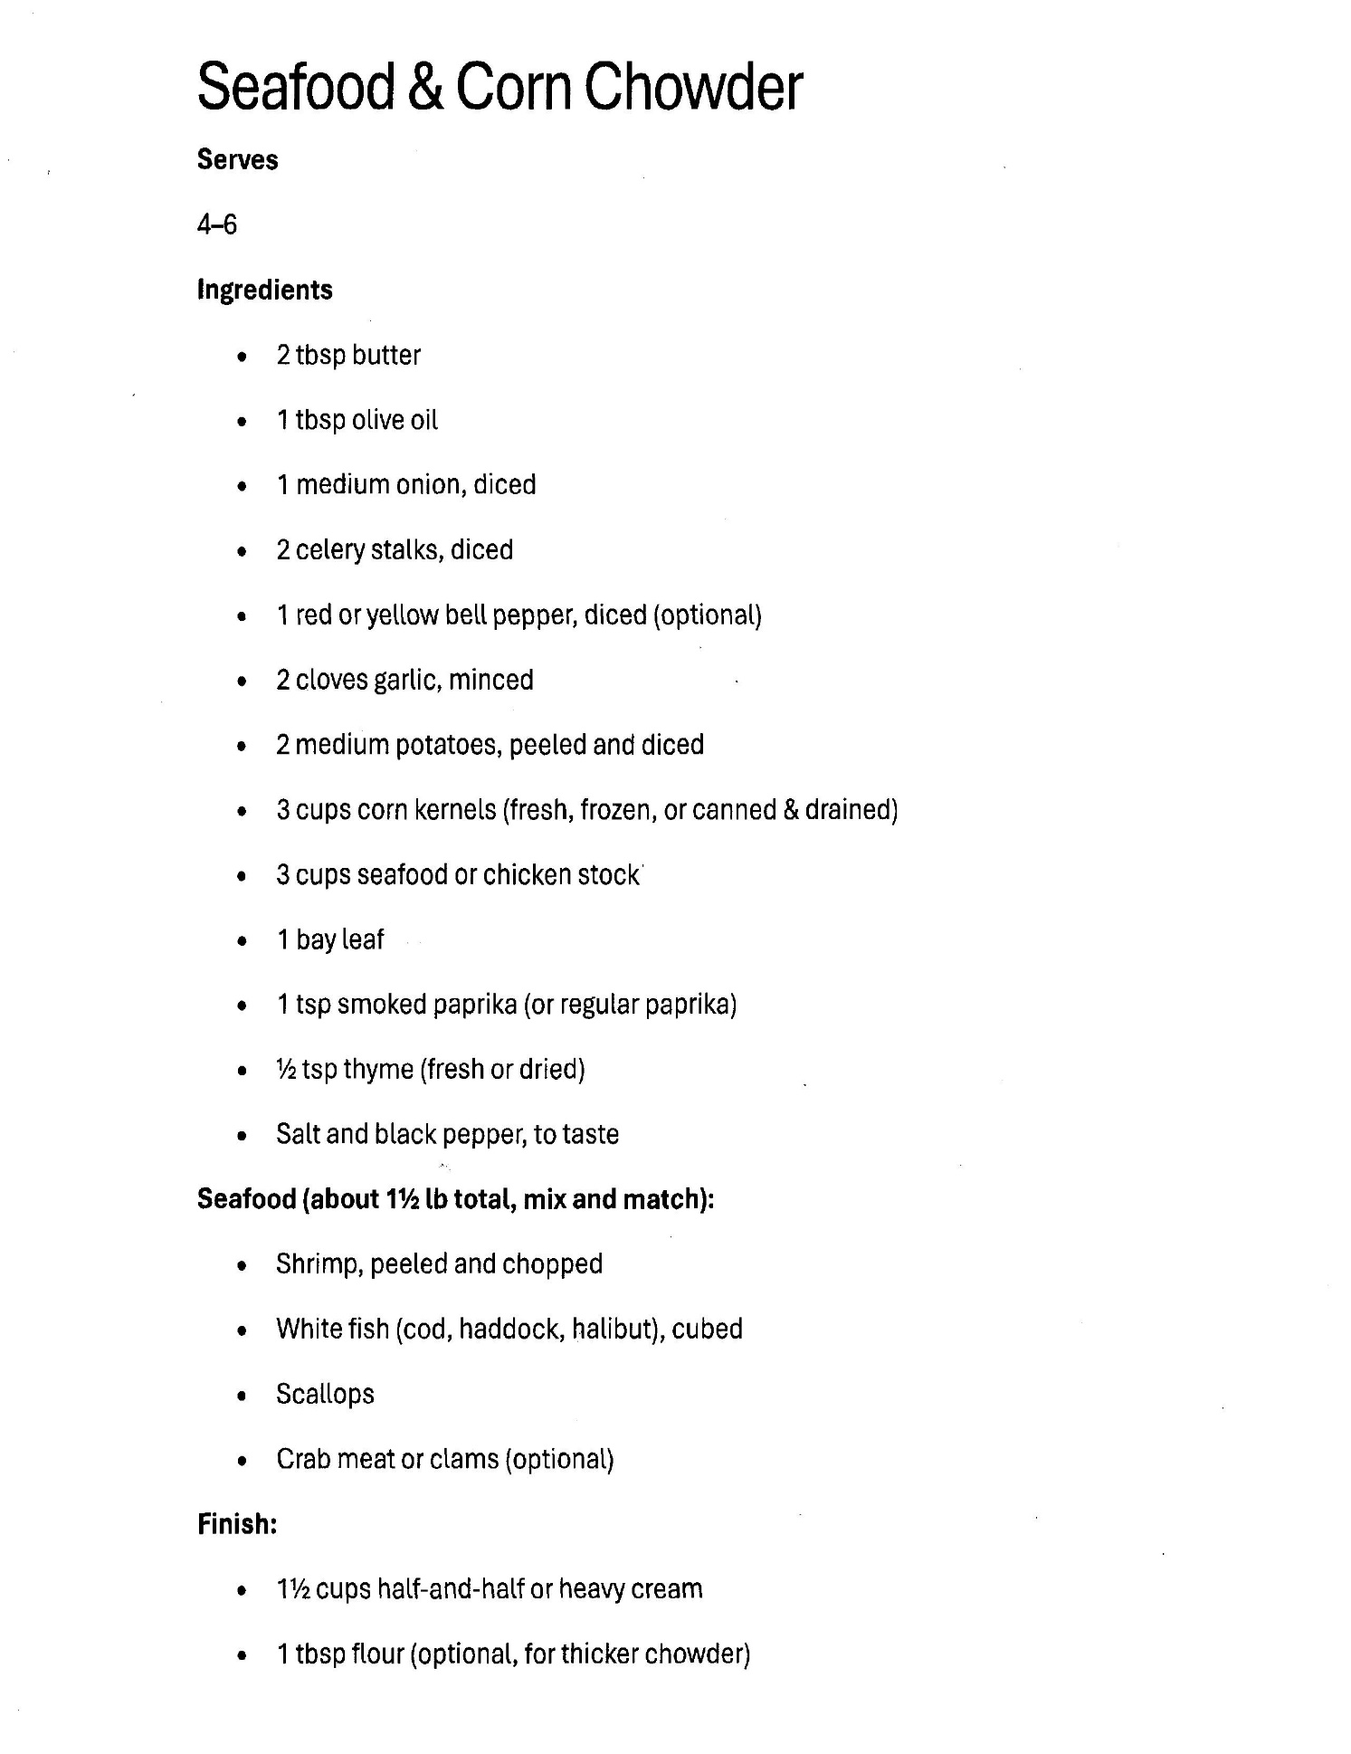

Seafood and Corn Chowder, (Page 2)

Directions.
- Sauté the Base: In a large pot or Dutch oven, melt 2 tablespoons of butter over medium heat. Add diced onion, celery, and bell pepper (if using). Sauté until softened (about 5 minutes). Add minced garlic for the last minute.
- The Flour (Your Optional Step): If you want that "heavy chowder" consistency, sprinkle the 1 tbsp flour over the sautéed vegetables and stir for 1 minute to cook out the raw flour taste.
- Simmer the Broth: Slowly stir in chicken or seafood stock (usually 3–4 cups) and your corn (fresh, frozen, or canned). If the recipe called for potatoes, add them now. Bring to a boil, then reduce heat and simmer for 10–15 minutes until potatoes are tender.
- Add the Seafood: Add your shrimp, white fish, crab, and scallops. Simmer gently for about 3–5 minutes. Do not overcook, or the seafood will get rubbery!
- Finish with Cream: Stir in the 1 1/2 cups half and half (or heavy cream). Let it heat through for 2 minutes, but do not let it come to a hard boil now that the dairy is in there, or it might curdle.
- Season and Serve: Season with salt, black pepper, and a dash of Old Bay or smoked paprika. Garnish with fresh parsley or chives.

