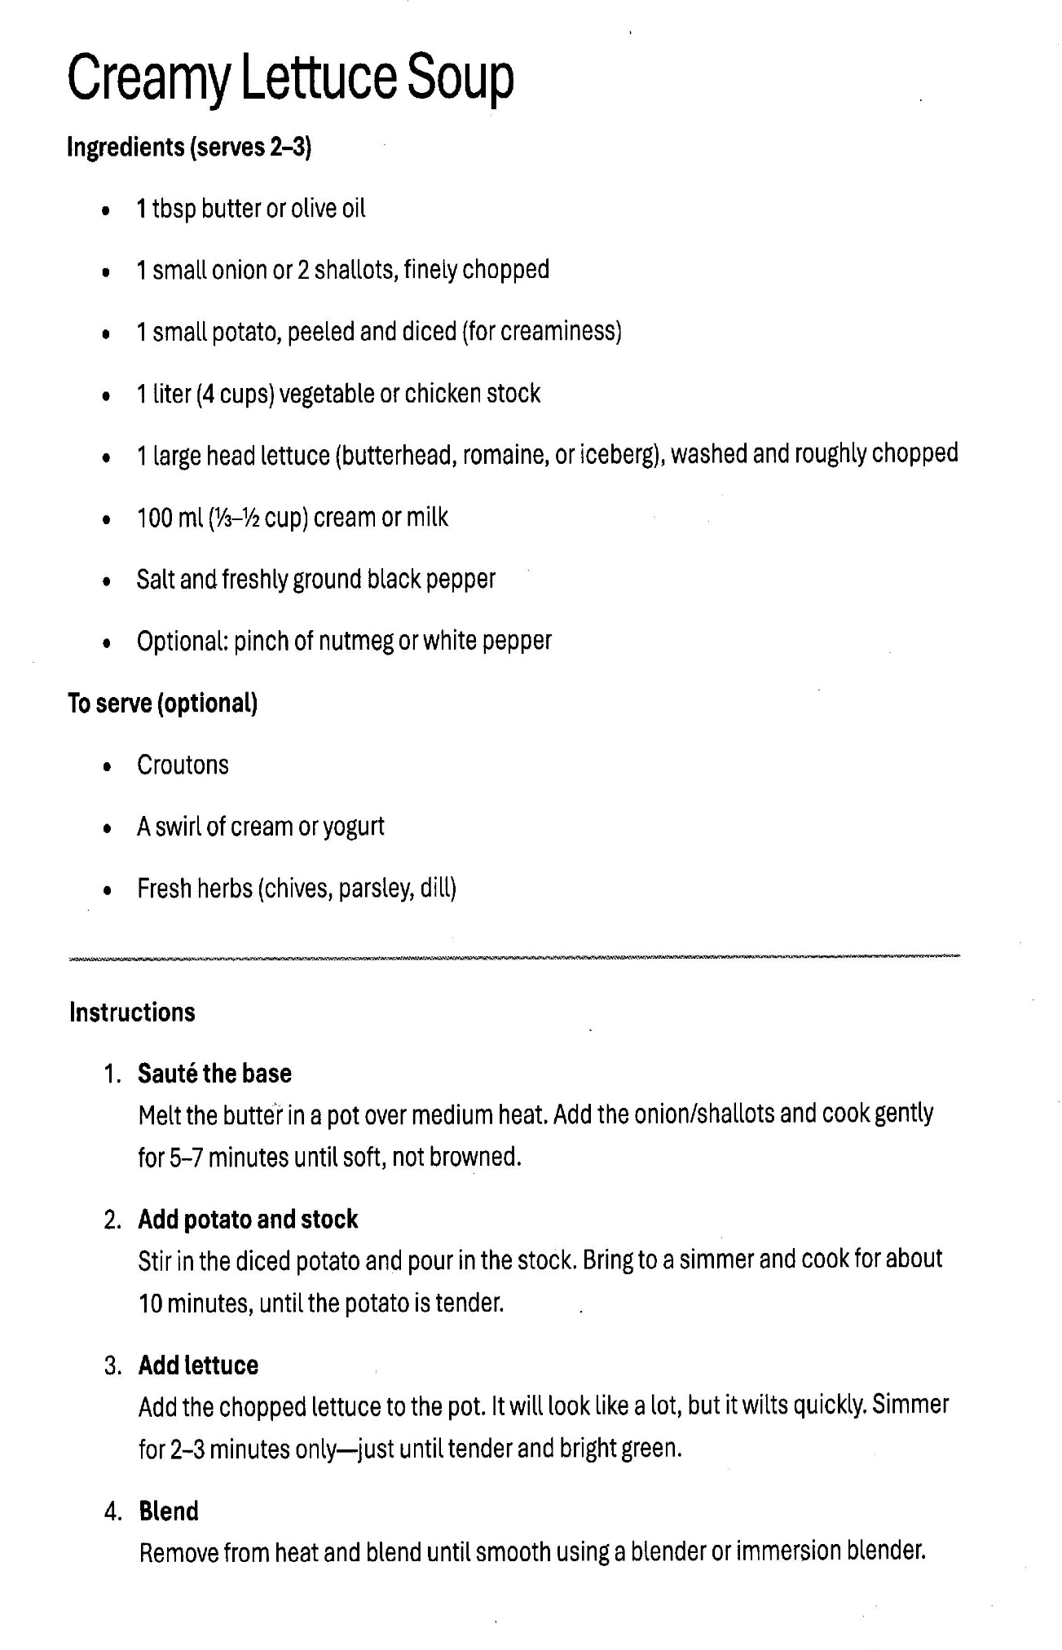

Creamy Lettuce Soup: page 2

5. Final Seasoning and Texture
- Strain (Optional): If you want a truly silky, restaurant-quality Creamy Lettuce Soup, pour the blended mixture through a fine-mesh sieve back into the pot.
- Adjust Consistency: If the soup is too thick, stir in a splash more stock or water.
- The "Secret" Seasoning: Stir in a teaspoon of fresh lemon juice or a dash of white wine vinegar. This acidity is crucial—it "wakes up" the flavor of the lettuce.
- Salt and Pepper: Season generously with salt and white pepper (white pepper keeps the soup looking bright green without black specks).

6. To Serve the Creamy Lettuce Soup
- The Swirl: Ladle the hot soup into bowls. Add your swirl of cream or yogurt in the center.
- The Toppings: Top with the croutons, chives, and fresh herbs (parsley or mint work beautifully here).
- Serve Immediately: This soup is best enjoyed fresh to maintain that vibrant green color; if it sits too long or is reheated too many times, the green will turn to a dull olive color.

