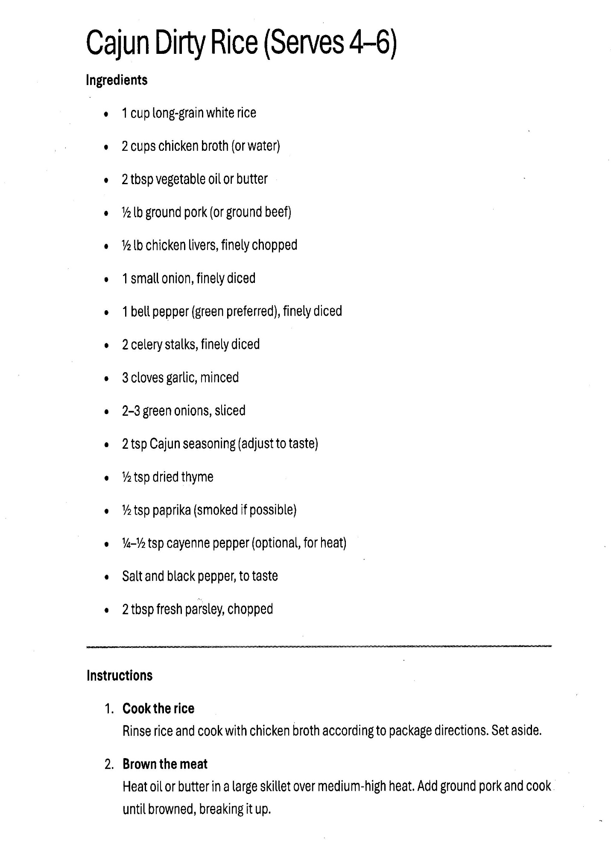
Cajun Dirty Rice, page 2

2. Brown the Meat (Continued)
- Drain: If there is excessive fat in the skillet, drain all but about 1 tablespoon.
Add finely chopped chicken livers to the skillet immediately after the ground pork has browned. * The Process: Once the pork is no longer pink, scoot it to the edges of the pan. Drop the chopped livers into the center.
- The Goal: Sauté them for about 3–4 minutes. You want them to turn brown and slightly crispy. As they cook, use your spatula to mash them slightly into the pork.
- If your ingredient list included minced chicken livers (the traditional way to make it "dirty"), add them now and cook for 2–3 minutes until browned.

3. Sauté the Vegetables (The Holy Trinity)
- Add Veggies: To the same skillet with the pork, add your diced onion, celery, and green bell pepper.
- Scrape the Pan: Cook for 5–7 minutes. Use your spatula to scrape up the browned bits from the pork—this adds massive flavor to the Cajun Dirty Rice.
- Aromatics: Stir in minced garlic and cook for 1 minute until fragrant.

4. Season and Simmer
- Spice it Up: Stir in your Cajun seasoning (or a mix of thyme, oregano, cayenne, and black pepper).
- Deglaze: Add a splash of chicken broth (about 1/4 cup) to the skillet to loosen everything up and create a light "gravy" that will coat the rice.

5. Final Assembly
- Combine: Fold the cooked rice into the skillet with the meat and vegetable mixture.
- Heat Through: Toss gently over medium-low heat for 3–5 minutes so the rice absorbs the colors and flavors of the meat and spices.
- The Finish: Stir in sliced green onions and fresh chopped parsley.

