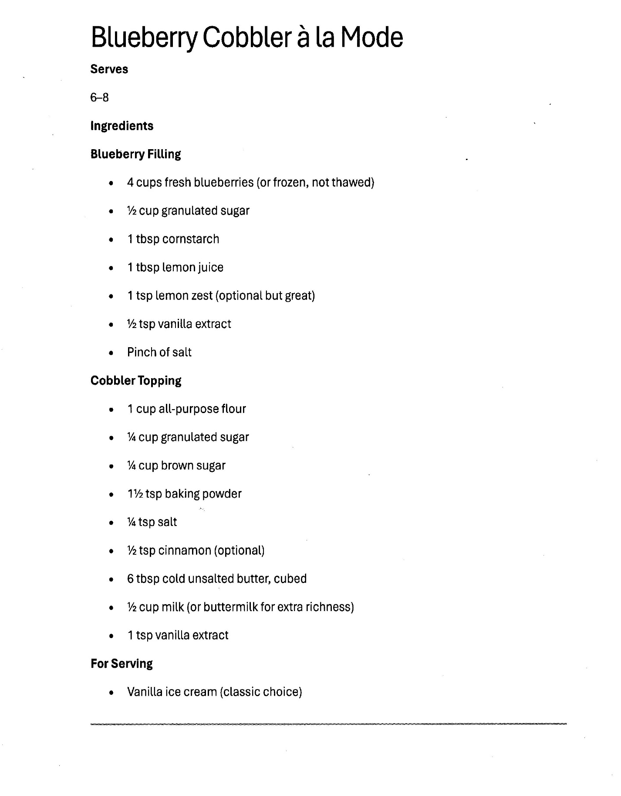

Blueberry Cobbler a la Mode (page 2)

Instructions for Blueberry Cobbler a la Mode
- Prep the Fruit: Preheat your oven to 375°F (190°C). In a medium bowl, toss the blueberries with 1/2 cup sugar, lemon juice, and cornstarch. Pour the mixture into a greased 8x8 inch baking dish or a deep-dish pie plate.
- Make the Topping: In a separate bowl, whisk together the flour, 1 cup sugar, baking powder, and salt. Add the beaten egg and use a fork to mix it until it looks like coarse, crumbly sand.
- Assemble: Sprinkle the flour mixture evenly over the top of the blueberries. Do not press it down—you want those crumbles to stay light!
- The Butter Drizzle: Pour the melted butter evenly over the entire topping. This is the secret to getting that crunchy, cookie-like crust on your Blueberry Cobbler a la Mode.
- Bake: Place in the oven and bake for 35–40 minutes until the fruit is bubbling and the top is a deep golden brown.
- Serve a la Mode: Let the cobbler cool for just 5–10 minutes so the juices thicken slightly. Spoon into bowls while still warm and top immediately with a large scoop of Vanilla Bean Ice Cream.

