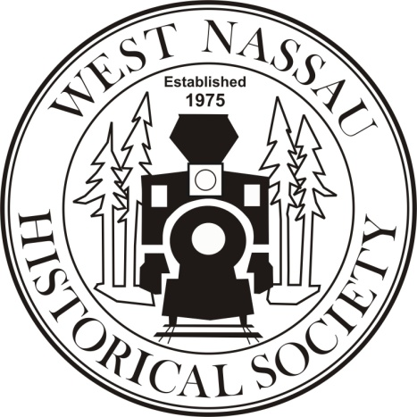
APPLICATION FOR THE
Nassau Art at the Callahan Depot
Art Exhibit
Presented by the West Nassau Historical Society
Thursday January 29, 2026 – Saturday January 31, 2026
Thursday, January 29, 2026, Opening Reception: 6:30PM – 8:00PM public invited
Friday, January 30, 2026, Student art awards & Exhibit open to the public 3:30:PM – 7:PM
Saturday, January 31, 2026, Exhibit open to the public 10:AM – 1:30PM
Award Ceremony: 1:30PM
Lunch provided for artists and their guests from Noon – 1:30
CAREFULLY PRINT OR TYPE YOUR INFORMATION AND
BE SURE TO SIGN THE ART SHOW RELEASE AGREEMENT ON THIS FORM.
Application deadline: Noon on January 20, 2026
NAME: ______________________________________________________________

ADDRESS: ___________________________________________________________

TOWN: ______________________________________ ZIP: _____________

EMAIL: _____________________________________________________________

PHONE: _____________________________________________________________

MEDIUM (Brief Description):

CATEGORY (Check or circle)

A. Oils
B. Acrylics
C. Watercolor
D. Pastels
E. Drawing
F. Photography/CGI
G. Three dimensional – please indicate size __________________

Are you willing to be on a waiting list if the number of entries exceeds our exhibit space? Yes______ No _______
Please list the titles of your entry pieces: Note: Once entered, titles cannot be changed.

- __________________________________________
- __________________________________________
- __________________________________________
EXHIBIT & PROCESS:
- Entry is open to any artist, ages 18 and over, residing within Nassau County, FL.
- Entries are limited to the categories listed above.
- Painting and photography entries and any wall art need to be ready hung. Entries must be backed with a wire hanging secured to eye bolts placed 1/3 of the distance between the top and bottom edge of painting.
- Each entry requires a business card size notation of the title of the work and the artist’s name.
- Each artist may enter up to 3 pieces. Past entries may not be re-entered. Members of the West Nassau Arts Alliance may enter up to 4 pieces.
- Photography entries are limited in size to a maximum of 20 inches X 20 inches or a total of 400 square inches.
- We encourage artists to sell additional art or reproductions of their art that fits one of the category descriptions. However, no for-sale pieces that are not official art show entries will be allowed in the judging area. Instead, an “art shop” area will be established where visitors to the art show can browse the pieces for sale. The “art shop” will be staffed by a WNHS volunteer for the duration of the art show. It is important that artists clearly identify their for-sale work with their name and indicate the pertinent sale prices. Note that the display of items for sale and the quantity displayed is solely at the discretion of WNHS. The art shop will be open for the duration of the exhibit.
- Fifteen percent of the sale price of each piece sold at the exhibit will be accepted as a donation to the West Nassau Historical Society.
- A jpg format image of each entry piece must be emailed to: margepowel@aol.com at the time of application. The email subject line should read: Nassau Art at the Callahan Depot. The jpg file names must match the titles listed above.
- Giclee prints are specifically excluded.
- Photographic computer modifications are allowed for photographic entries.
- Applications that cannot be matched to images will not be accepted.
- Applications without a signed release (see below) will not be accepted.
- Jpg images will be deleted with no copies retained on or by February 5, 2026.
- Each entry, as appropriate, may tastefully display a sale price.
- The Art will be judged by professional artist(s). First, Second, and Third place designations will be awarded for the following categories:
  - Painting – including oils, acrylics, watercolor, pastels, and drawing
  - Photography – color and black & white
  - Three-dimensional art
- A minimum of 3 entries in a category by at least 2 different artists is required before the full complement of 1st, 2nd, and 3rd places are awarded. In the event the entries in a category are less than the minimum, the judge(s) will grant awards they deem to be warranted. The judges reserve the right to withhold awards in either of the 3 categories
- The winning entries in the painting and photography categories will be displayed at select venues in Nassau County for a limited period after the art exhibit. Transport of the winning entries to these venues will be provided by WNHS provided the artwork fits in the vehicle used for transport. West Nassau Historical Society assumes no liability for any damage during transport.
- Art may be delivered to the Callahan Depot according to the following schedule:
  - Monday, 1/26/26, 1:PM – 3:PM
  - Tuesday, 1/27/26, 3:PM – 5:PM
  - Wednesday, 1/28/26, 5:PM – 7:PM
Entries outside of this schedule will not be accepted unless special arrangements are made. Admittance to the display area will be limited to only Art Show Committee members.
- Placement of the entries for display is at the discretion of WNHS.
- Art must be removed by the artist after the Award ceremony as soon as possible on Saturday afternoon, except for the winning entries.
- The awards ceremony will be at 1:30, Saturday, January 31, 2026, at which time the awards will be presented, and sales finalized.

ART SHOW RELEASE
The undersigned hereby releases and forever discharges and holds harmless the West Nassau Historical Society of and from any and all manner of actions, suits, damages or claims whatsoever arising from the loss or damage to the property of the undersigned while in the possessor supervision of the West Nassau Historical Society including during the transport of winning entries to the county wide venues. The undersigned hereby consents to the enforcement of the Art Exhibit rules as set down in this document. Art in the exhibit may be available for sale. By signing this release you understand that no liability is assumed by the West Nassau Historical Society and you certify that any of the art for sale or display in your name was not created by others. If it is found that any piece of art was created by others, it will cause your immediate expulsion from the Art Exhibit by the West Nassau Historical Society. The undersigned also grants permission for general photos of the art exhibit which will be used only for publicity purposes and may or may not include a portion of the submitted artwork.
Signature ____________________________________ Date _________________
I will be bringing works for sale in addition to my entries: _______ yes _______no
Artists should bring only their most salable items knowing that space is EXTREMELY limited and not all their salable merchandise may be displayed.
CHECK LIST OF ITEMS THAT MUST BE SUBMITTED
1. Signed Application.
2. Registration Fee - $25.00 (Non-refundable) for up to 3 entries.
3. Images in JPG format emailed as outlined above.
4. Mail signed application and entry fee to:
West Nassau Historical Society, P.O. Box 1758, Callahan, FL 32011
All other communications will be via email to margepowel@aol.com
Where did you hear about Nassau Art at the Callahan Depot?

Previous entrant ______
Another art organization ______
Newspaper ______
Social Media _____
Word of mouth ___
Other ____

