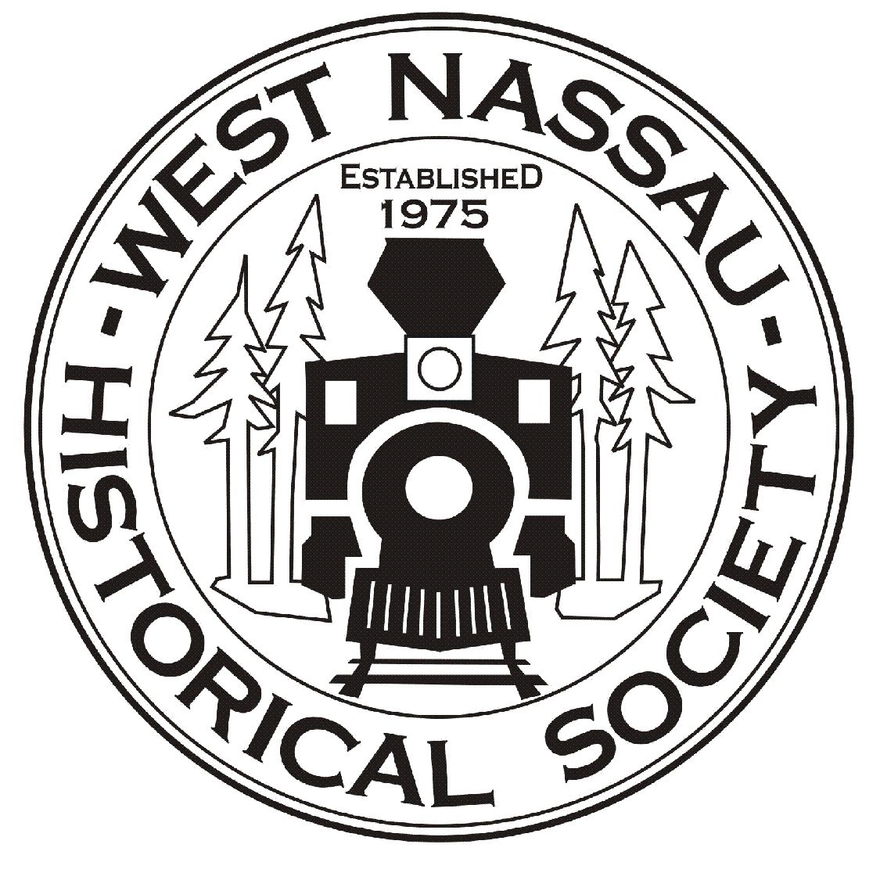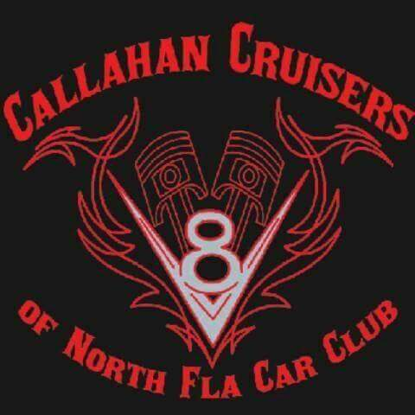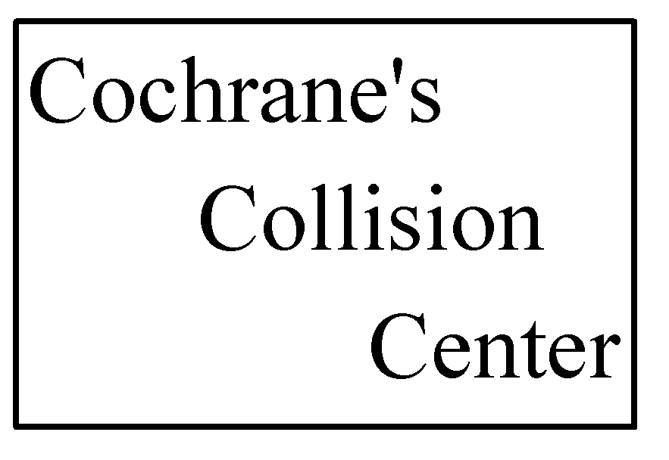
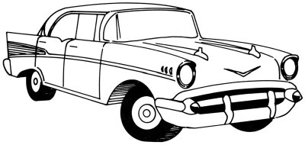
2025 RAILROAD DAY
FESTIVAL AND CAR SHOW
SATURDAY, March 29
CAR SHOW 10A-2P
Awards Ceremony at 2 pm
PAY DAY OF SHOW!!!!!
At the Historic Callahan Depot, Pavilion,
And Cochrane’s Collision Center
45383 Dixie Ave and 617473 Brandies Ave
FESTIVAL 9A-4P
Kids Area – Live Entertainment
FOR MORE INFO, CALL 904-879-6456
(See form on back for car show entry fees)
2025 RAILROAD DAY
CAR SHOW REGISTRATION FORM
Name________________________________________
Address______________________________________
City/State/Zip_________________________________
Email________________________________________
Phone________________________________________
Car Make________Model_______________Year_____Color______
Car Show Entry Fee $20
PAY DAY OF SHOW!!!!!
Prizes awarded in various categories.
This Car Show is presented by Callahan Cruisers
and Cochrane’s Collision Center as a fundraiser for
the local nonprofit West Nassau Historical Society.
The Historical Society’s mission is to highlight and promote our county’s rich and diverse history and to maintain the historic 1881 Callahan Train Depot located on 45383 Dixie Ave. For more info visit www.wnhsfl.org

